Graphing System
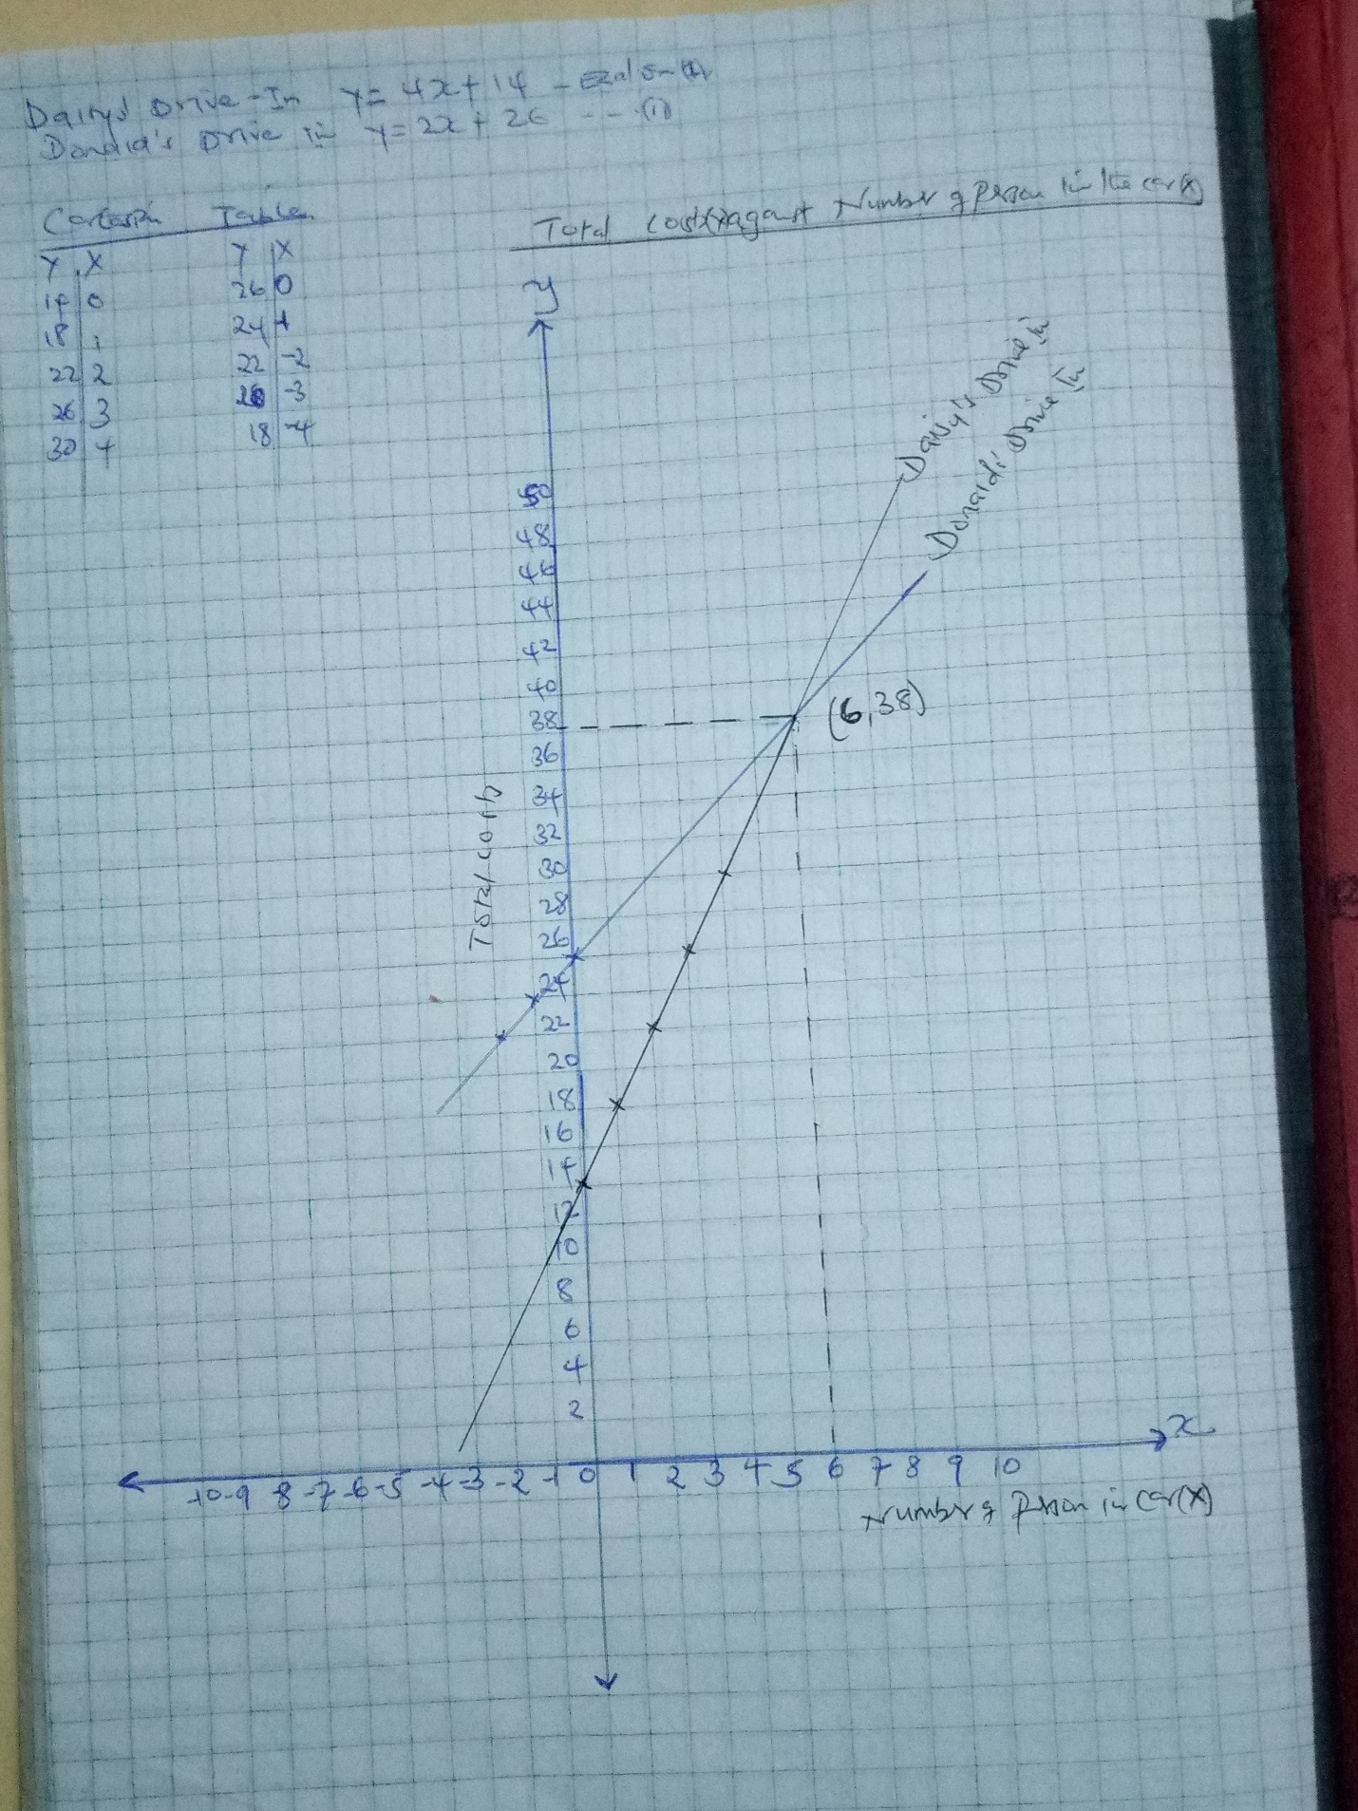
3. What is the point of intersection on your graph? What do you think this means in context of the problem? Answer in complete sentences
The point of intersection on my graph is (6, 38) in form of (x,y). Intersection points indicates a better deal point for both drive in Movie Theater.

4. Compare and contrast the theatre options. When will Daisys be a better deal (meaning, when the total cost is less)? When will Donald’s be a better deal? Explain how you know. Answer in complete sentences
y= 4x+14 but we know the value of y and x
38= 4(6) +14
38= 38
Therefore the Daisy’s better deal when be achieved when the number of number if cars is less than 4
y = 2x+26
38= 2(6) +26
38= 38
Thus Donald’s better deal is when the number of cars is less than 2.
Depending on the amount of people in the car determines numbers of the equation so variable had to be placed instead.

